**MÚSICA DEL PACÍFICO**

Herencia de Timbiquí <https://www.youtube.com/watch?v=BuBrF_npl_g>

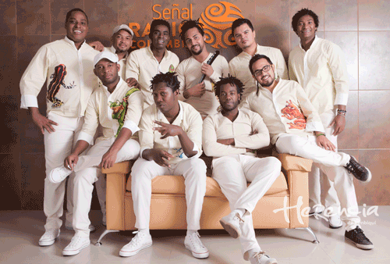

Grupo Bahía <https://www.youtube.com/watch?v=GTN3mJ1OaHM>

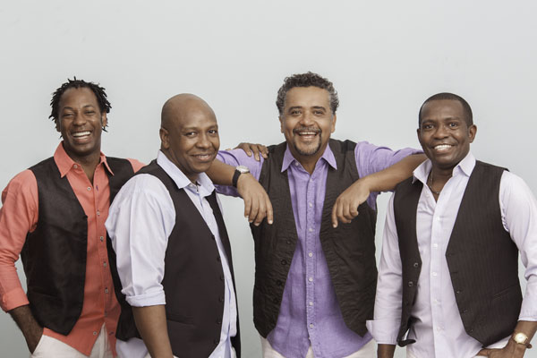

Chocquibdown <https://www.youtube.com/watch?v=NemwE1YoTRM>

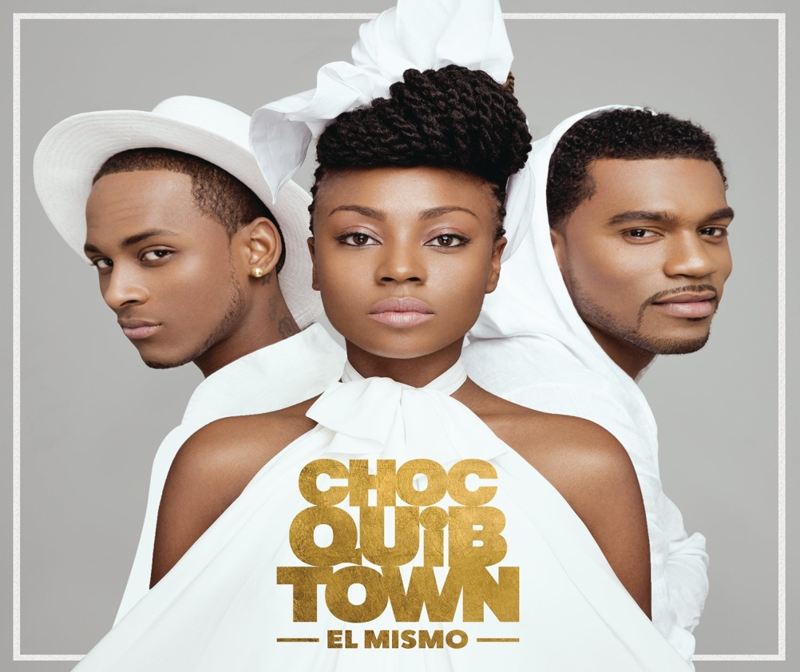

Cununo <https://www.youtube.com/watch?v=A4Ga52Q2cPY>

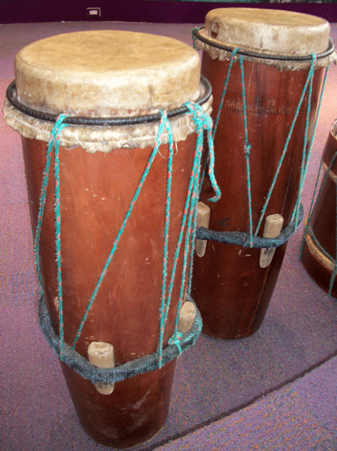

Guasá <https://www.youtube.com/watch?v=yBsc6NHJs-I>

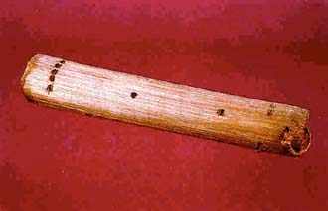

Marimba <https://www.youtube.com/watch?v=gEPw7sFDZEs>

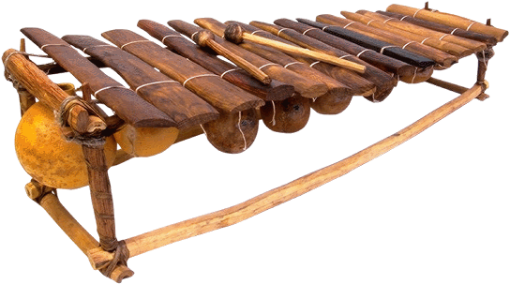

Afroson con Bombo, Cununo, Marimba y Guasá

<https://www.youtube.com/watch?v=BOXqf2PDv_s>